**9-25-23 notes**

Introduction to Python

Module 3.1 goals:

By the end of this lesson, you will be able to:

* Confirm that Python 3 is correctly installed.
* Navigate to folders on your computer by using the command line.
* Create Python scripts and run them in the terminal.
* Perform basic programming tasks by using conditional statements and lists.

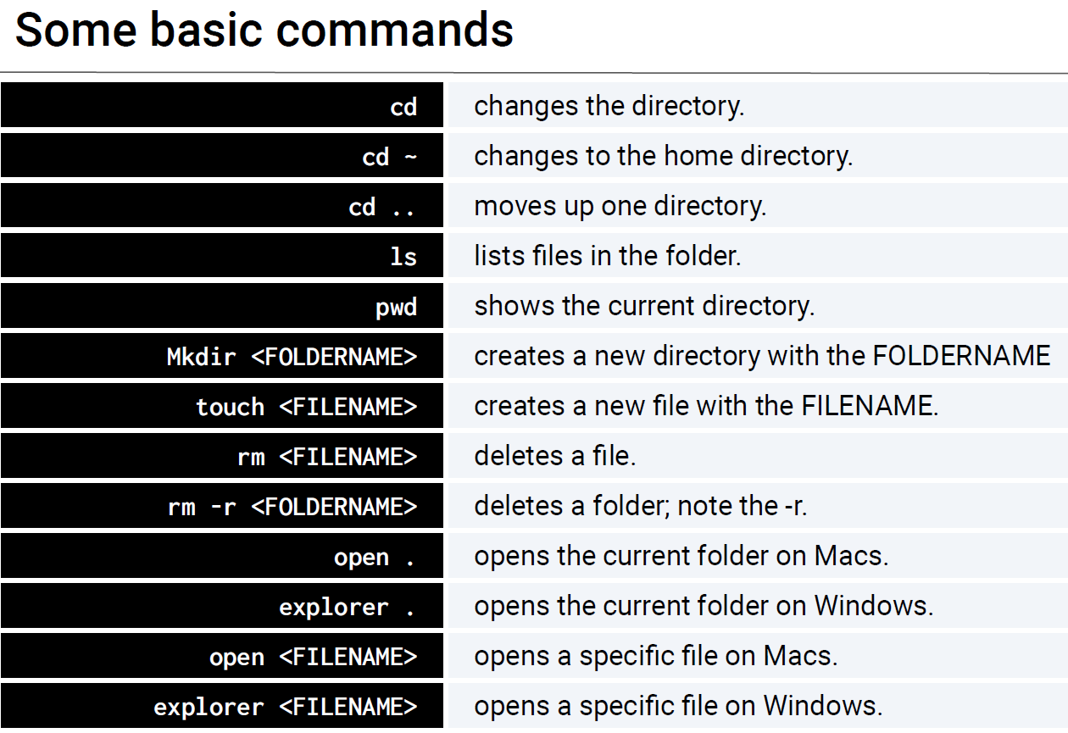

CLS command clears screen

ECHO is the windows command to make a new file, not TOUCH

PWD stands for Present Working Directory

NOTEPAD makes a new file (see below)



^Makes a new file in notepad if one doesn’t already exist. Opens file if one exists.



Opens Python file Print.py and executes code in the file.

**Virtual environments:**

Virtual environments keep projects separate. One version of language per environment.

You can have a different environment using a newer/older version of language for a given project

**Creating variables:**

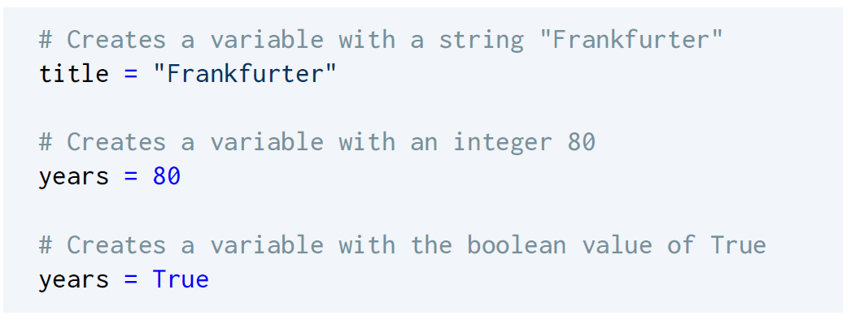

**Print statements:**

F-string relies on computer to figure out data type.

Example 3 below shows manually assigning data type.

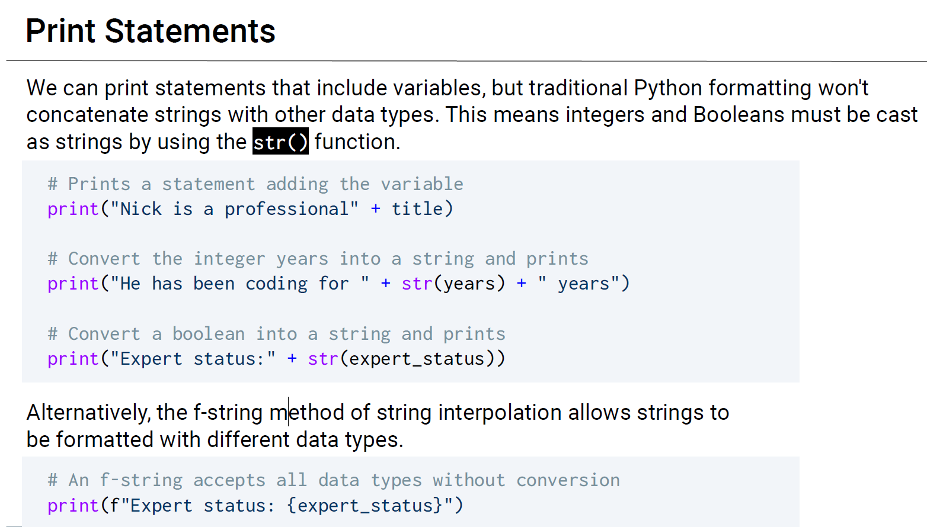

^ F-strings are the norm in business, using pluses may be required for homework, but F-strings are the best thing in the history of Python

**Inputs:**

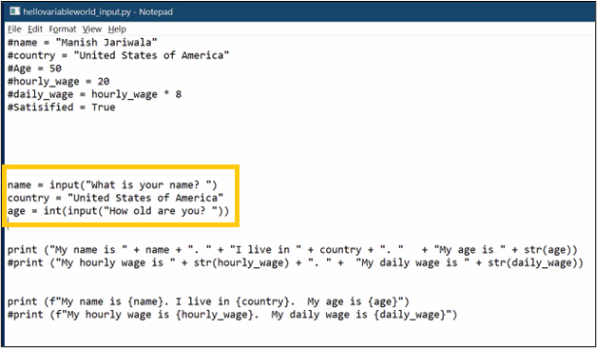

# comments out a line, like apostrophe in VBA

^important part of this code is the “name =” and “age =” lines

**Conditionals:**

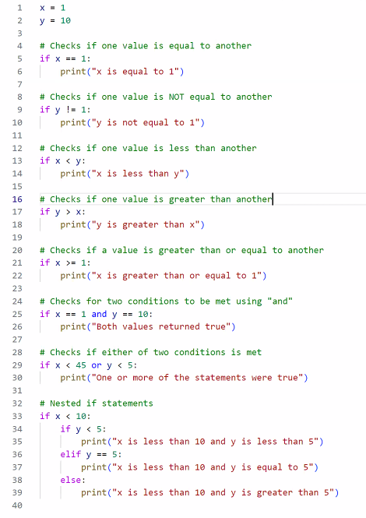



== means that it’s checking Left to Right

= is assigning a value on the right to the variable on the left

**TABS ARE REQUIRED**

!= means not equal to

* In VBA that’s <>

>= greater than or equal to

Elif is the equivalent to VBAs elseif

** is the same as ^ (raising to the power of)

From the slideshow:

* Conditionals in Python feature nearly the same logic as VBA. The primary differences are the syntax and indentation.
* Python uses if, elif, and else to create contionals.
* Conditional statements are concluded with a colon. Because Python reads blocks of code based on indentation, all lines after the colon **must** be indented to be considered a part of that code block.
* All sorts of operators, like greater than, less than, and equal to, can be used to create logic tests for conditionals.
* The condition is equal to uses ==, while variable assignment uses one equal sign.
* Multiple logic tests can be checked within a single conditional statement. If we use the term and, both tests must return True, while or requires that only one test return as True.
* Conditionals can even be nested, allowing programmers to run logic tests based on whether or not the original logic test returned as True.

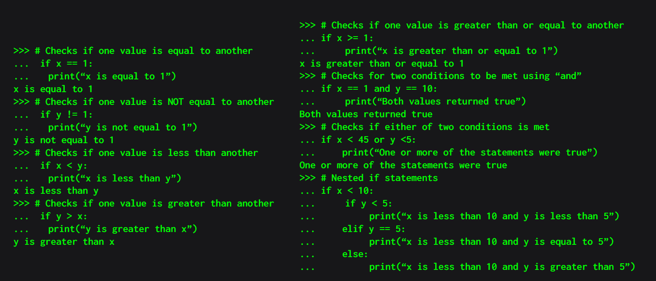

**Conditionals:**

>>> # Checks if one value is equal to another

... if x == 1:

... print(“x is equal to 1”)

*x is equal to 1*

>>> # Checks if one value is NOT equal to another

... if y != 1:

... print(“y is not equal to 1”)

*y is not equal to 1*

>>> # Checks if one value is less than another

... if x < y:

... print(“x is less than y”)

*x is less than y*

>>> # Checks if one value is greater than another

... if y > x:

... print(“y is greater than x”)

*y is greater than x*

>>> # Checks if one value is greater than or equal to another

... if x >= 1:

... print(“x is greater than or equal to 1”)

*x is greater than or equal to 1*

>>> # Checks for two conditions to be met using “and”

... if x == 1 and y == 10:

... print(“Both values returned true”)

*Both values returned true*

>>> # Checks if either of two conditions is met

... if x < 45 or y <5:

... print(“One or more of the statements were true”)

*One or more of the statements were true*

>>> # Nested if statements

... if x < 10:

... if y < 5:

... print(“x is less than 10 and y is less than 5”)

... elif y == 5:

... print(“x is less than 10 and y is equal to 5”)

... else:

... print(“x is less than 10 and y is greater than 5”)

**Lists:**

Lists are the same as Arrays in VBA

EXCEPT: Lists can hold lists

Lists use square brackets, NOT PARENTHESIS

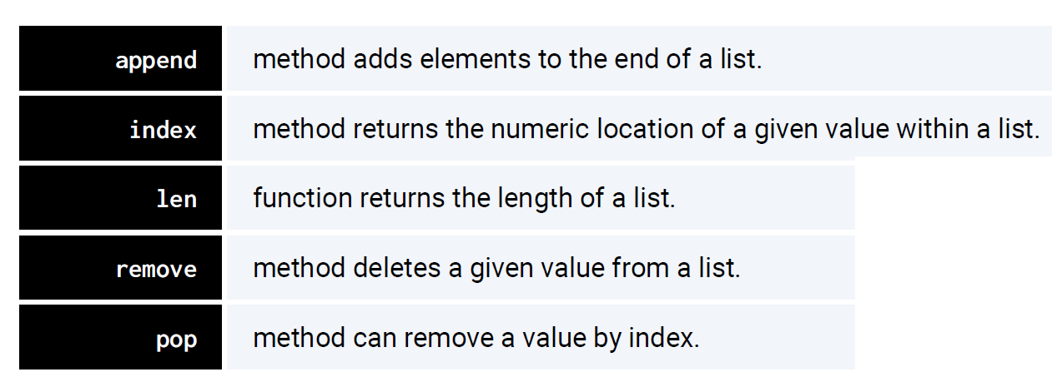

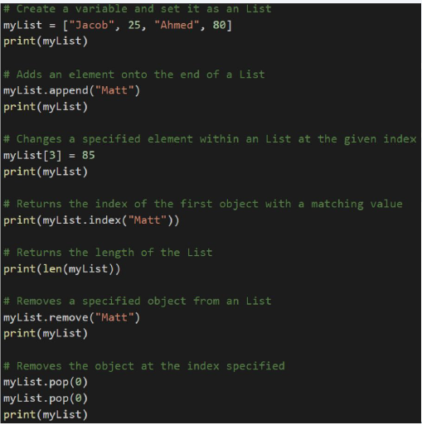

**Tuples:**

Tuples are lists that cannot be modified after they’ve been declared.

Tuples use parenthesis, NOT BRACKETS

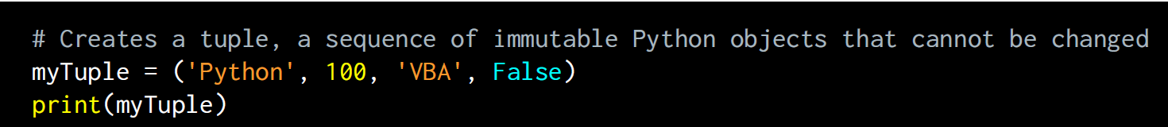

**Import**

Imports a library of logic

Math is a library that is already included without importing

**Rock Paper Scissors activity:**

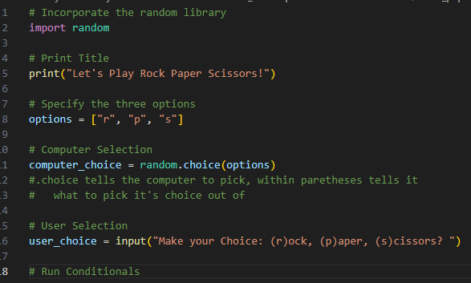

**For/Loops:**



Prints out 0, 1, 2, 3, 4 as a new line for each number, no commas. Just the numbers

Prints out a line of dashes

Prints out numbers 2 through 6

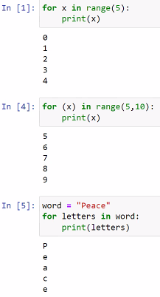

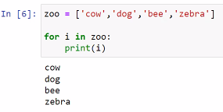

**PYTHON MAKES EVERYTHING AS A LIST before working with it**

**While loops:**

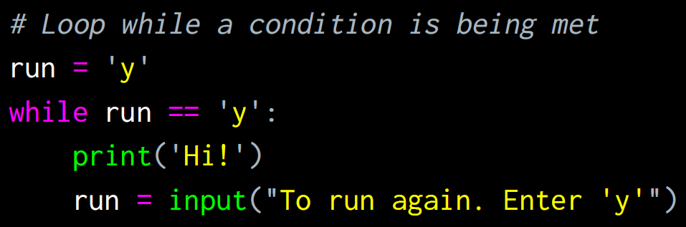

**From Alyssa (Mac user TA):**

Command line (Terminal, Powershell): computer, without all the pretty pictures. make files, write to files, run code, navigate through directories, and a whoooole lot more.

Python: a programming language. you write code into a .py file, Python compiles and runs it (or gives you an error message). you can do a LOT with it!

Anaconda: Python, plus a bit more. adds more data science tools, and more.

Anaconda Navigator: application that lets you do some of the package management, updating, environment, etc. stuff with Anaconda without the command line.

TextEdit, Notepad: text editors. lets you write to files, and that’s about it.

VSCode: an “integrated development environment”. like a text editor, and lets you skip the command line for running files, creating files, etc. too

Jupyter Notebook: a slightly different kind of coding environment. you can write and run blocks of code at a time, and add markdown / text blocks as well.